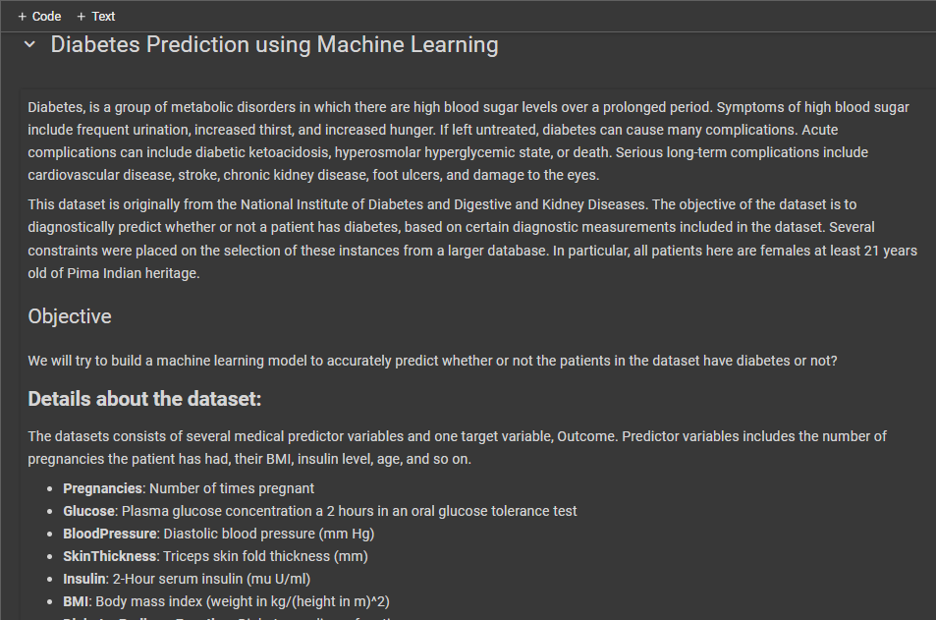

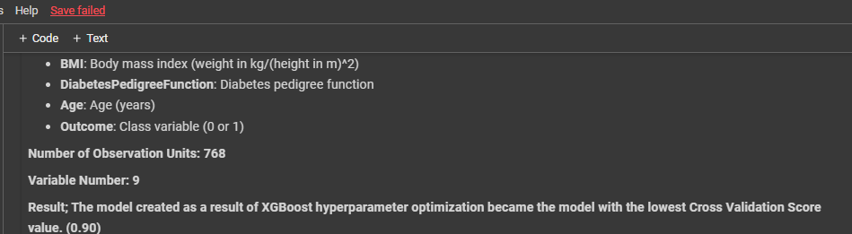

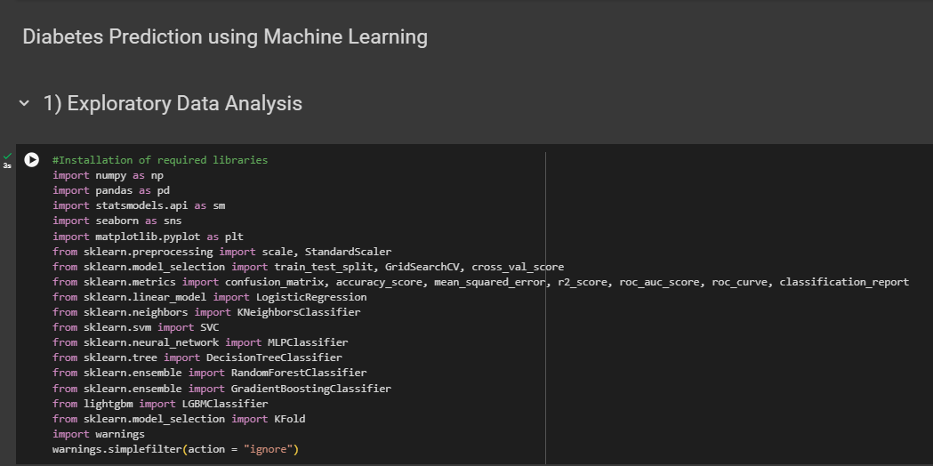

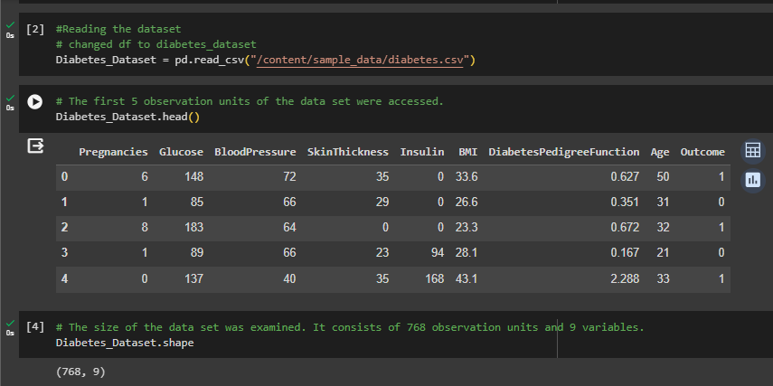

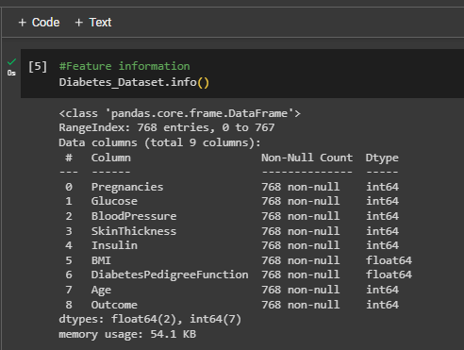

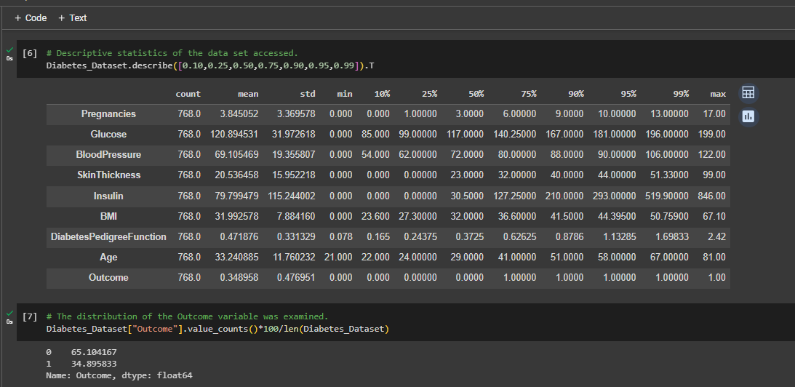

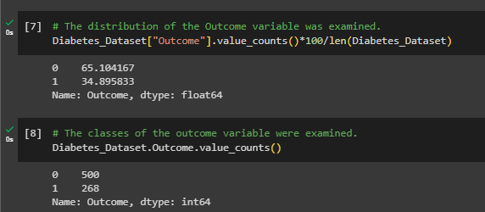

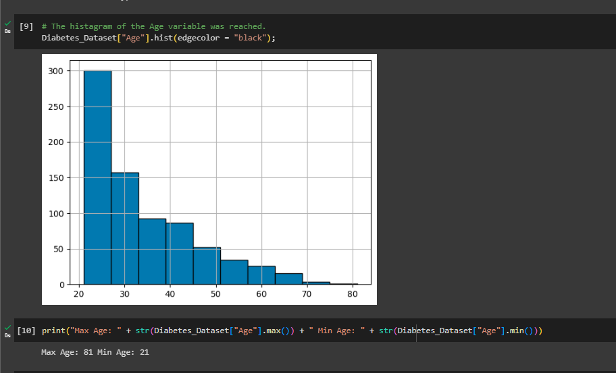

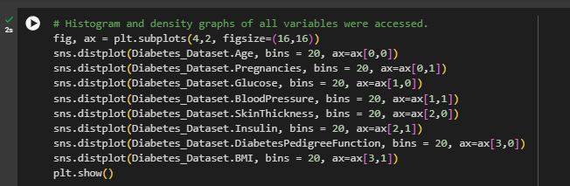

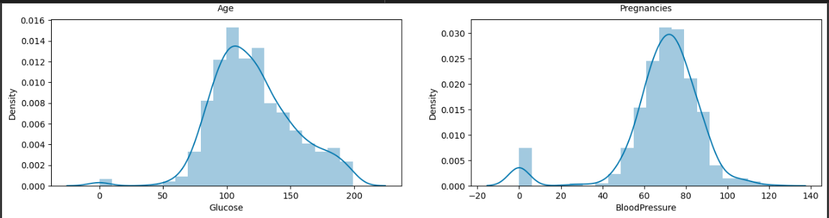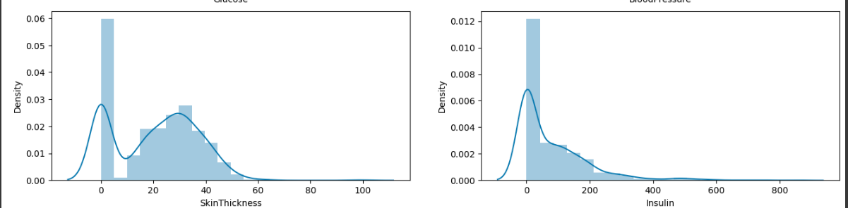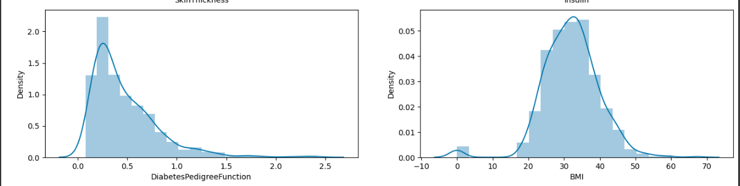

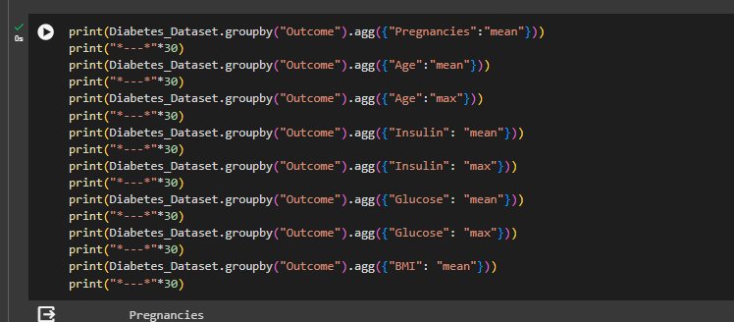

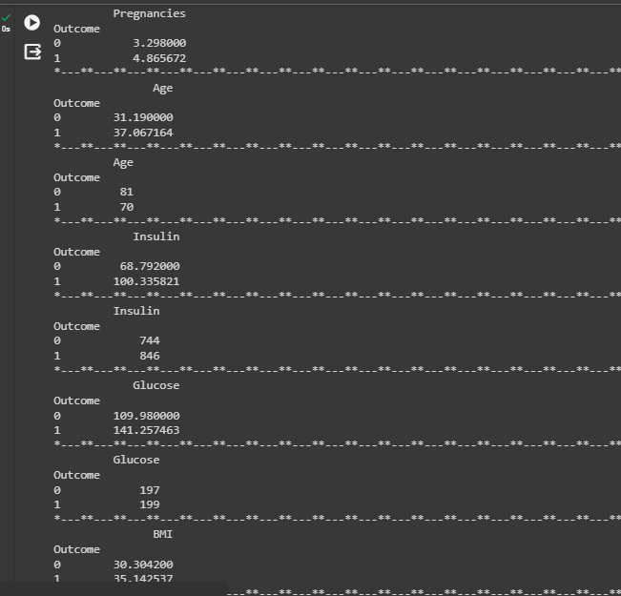

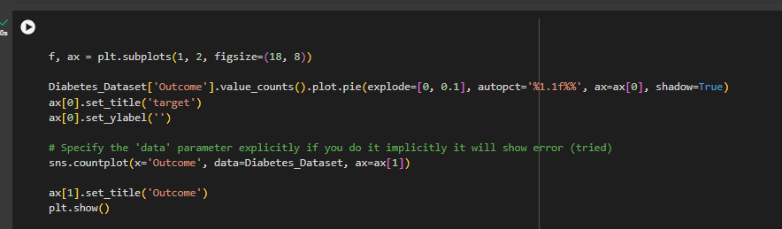

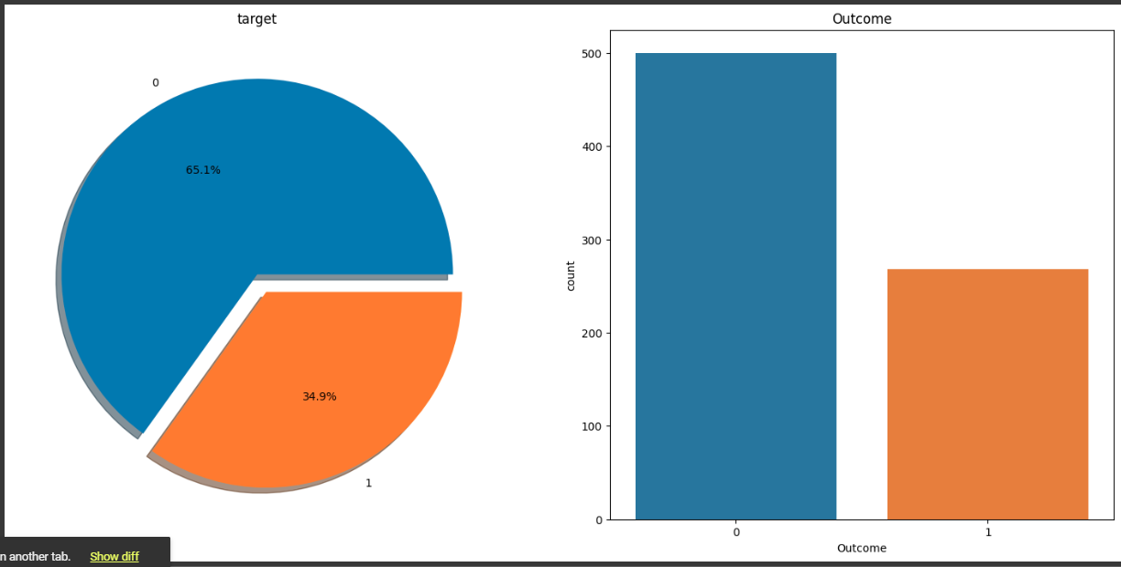

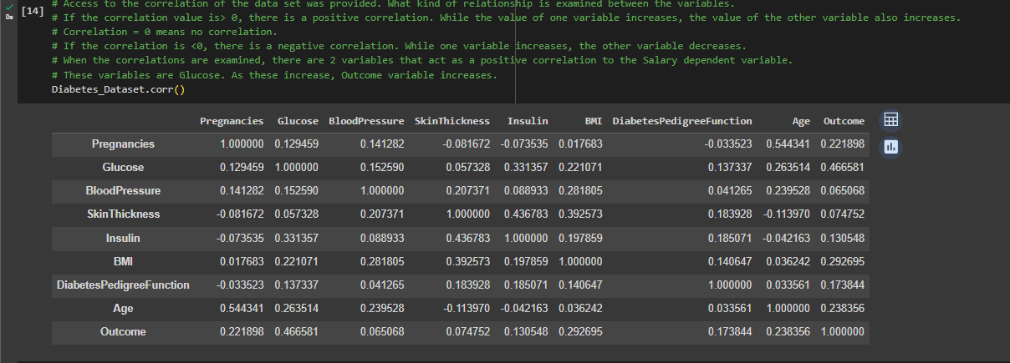

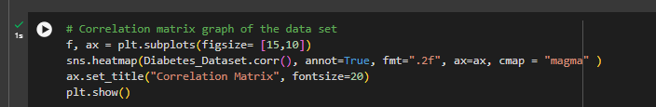

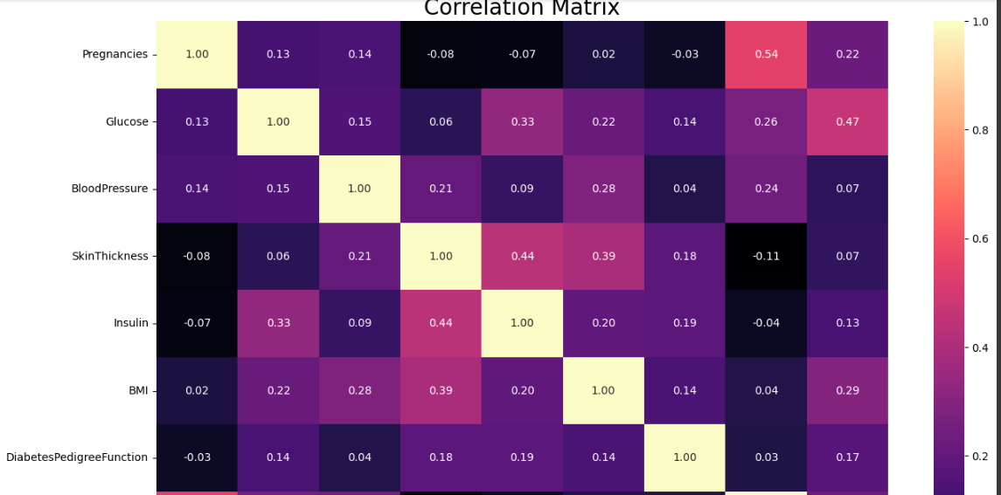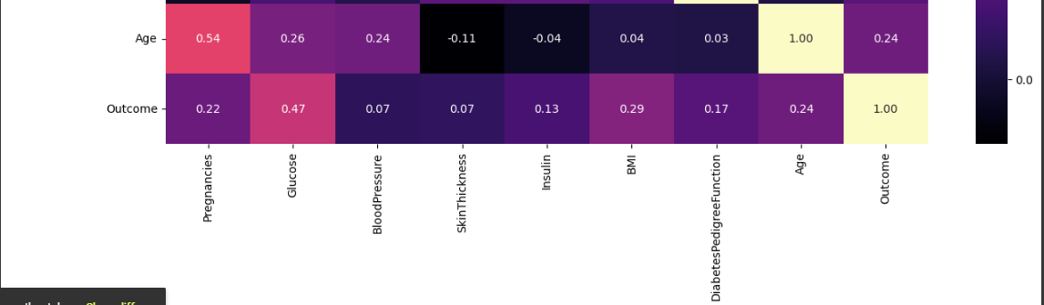

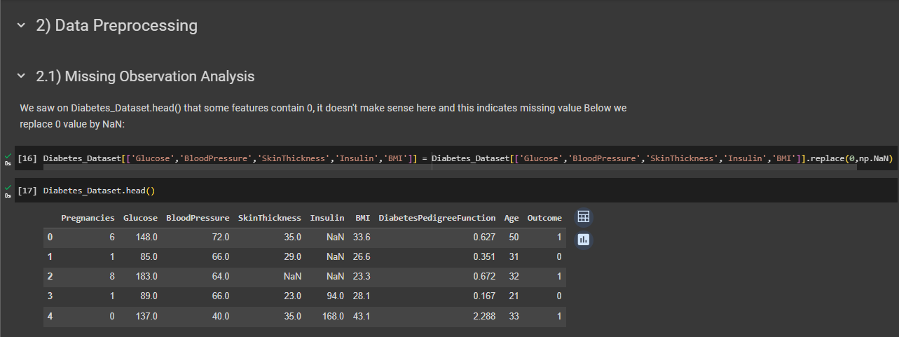

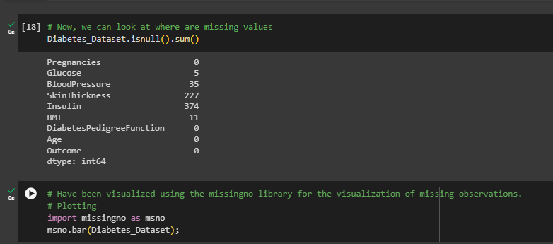

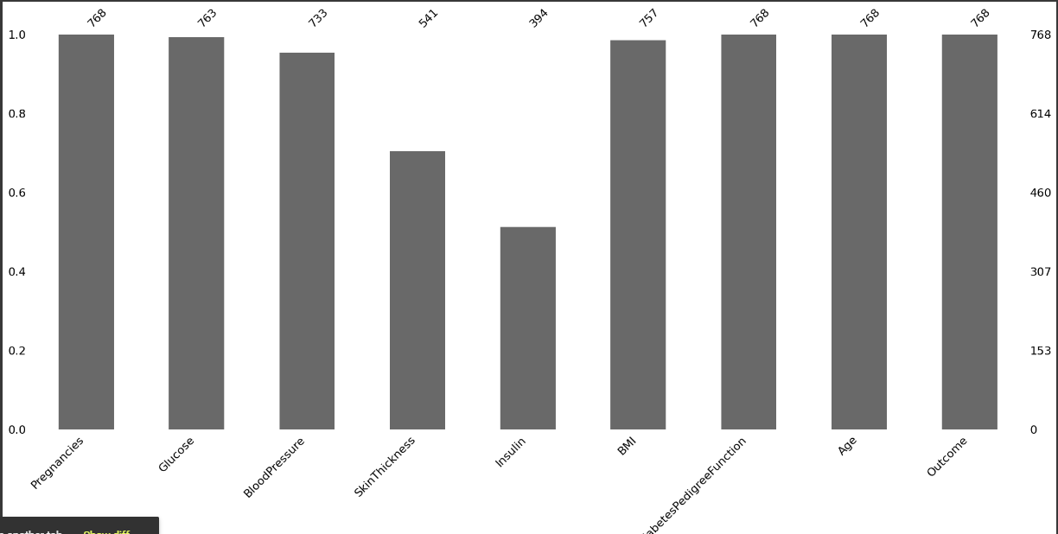

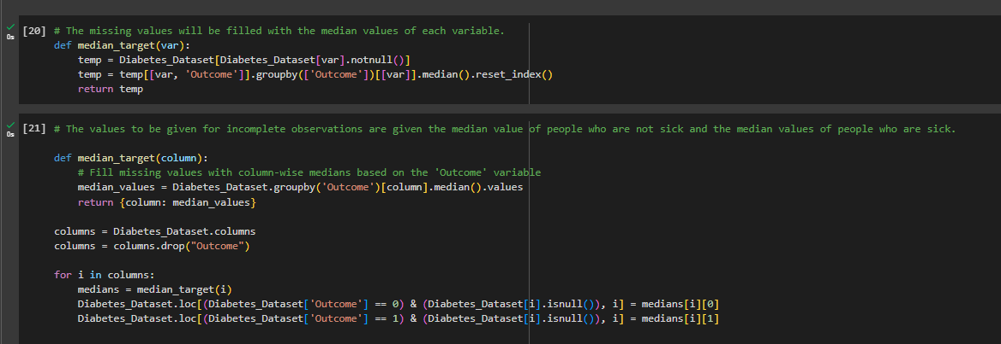

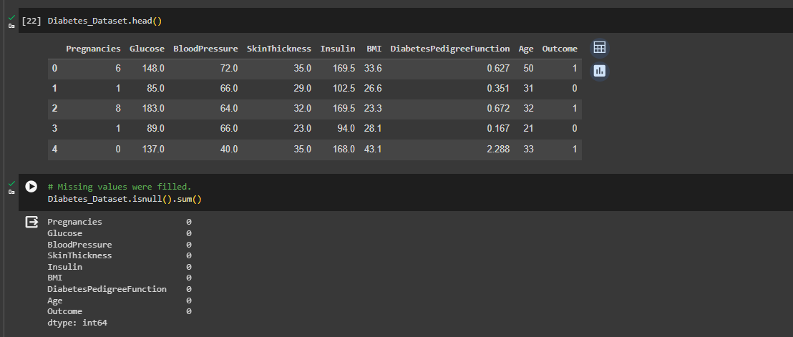

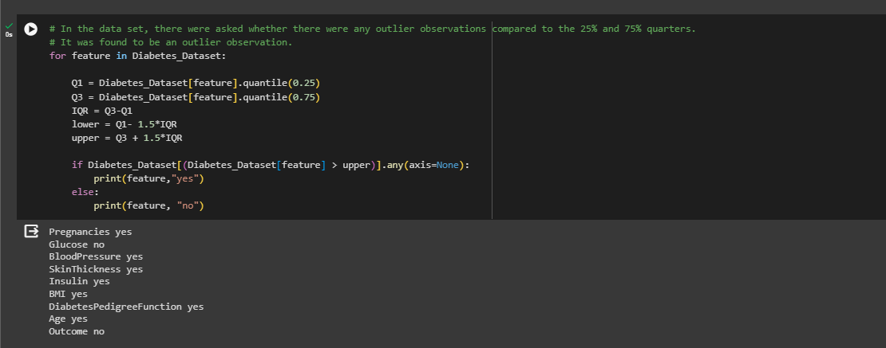

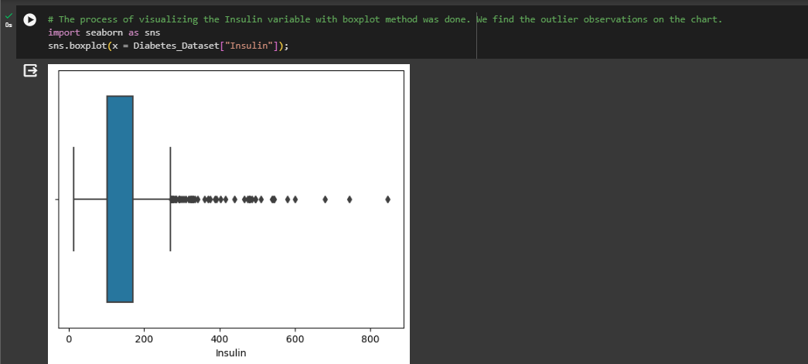

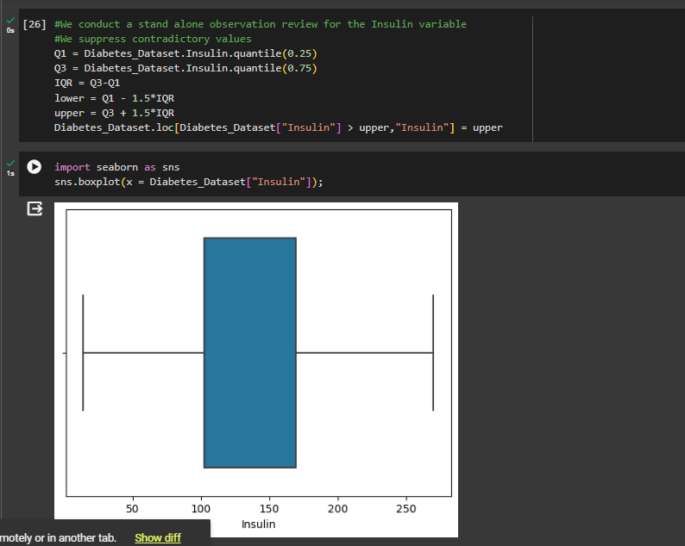

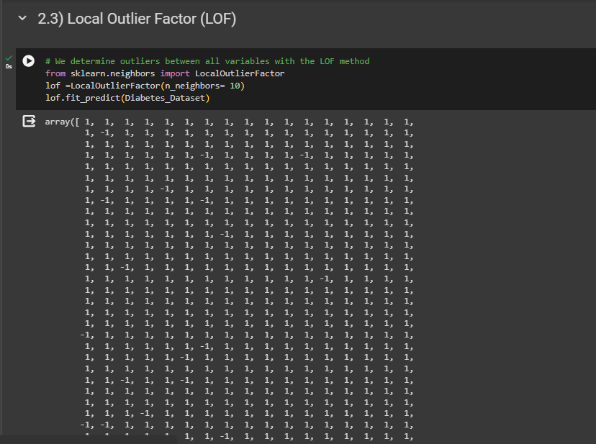

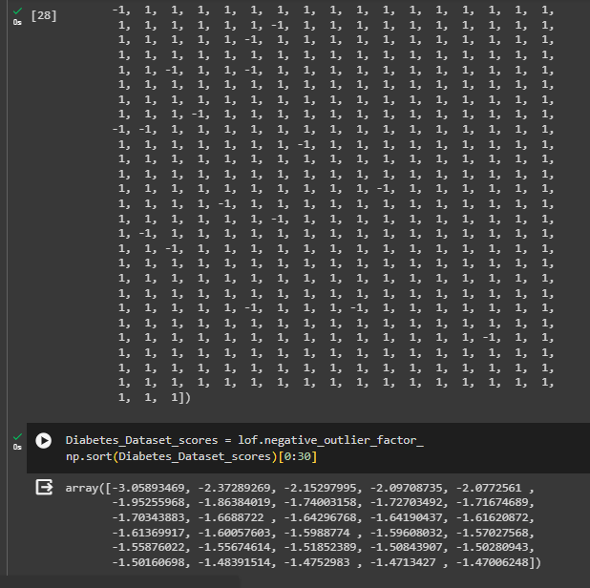

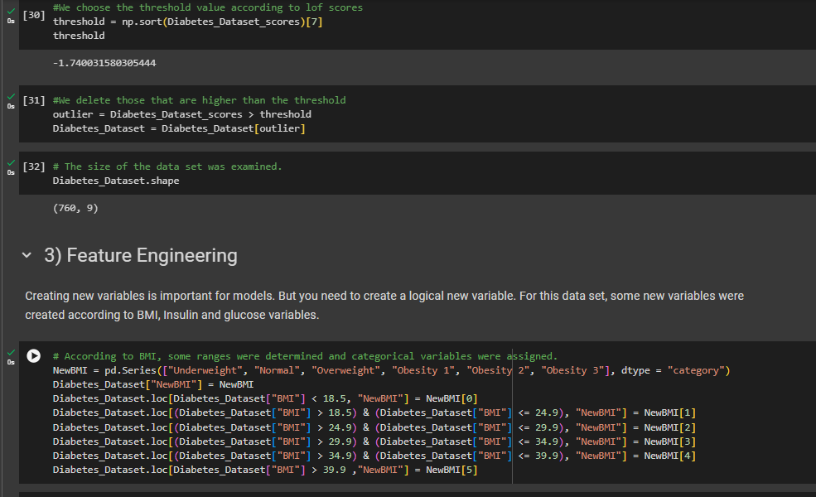

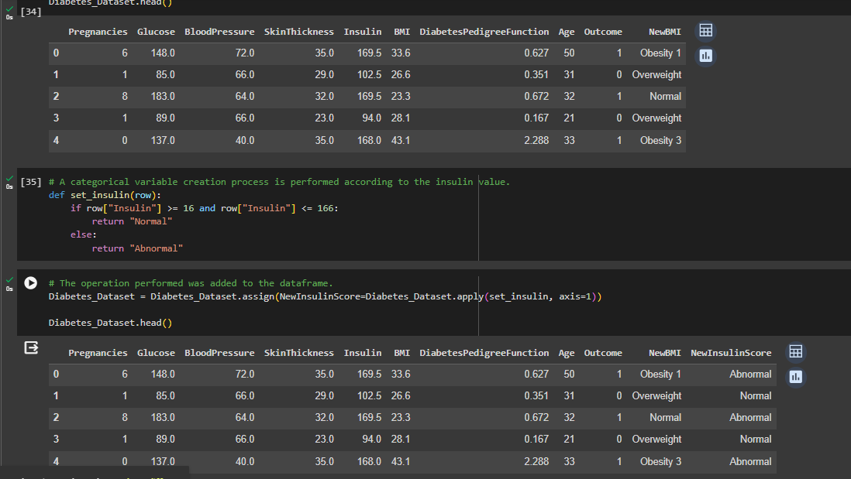

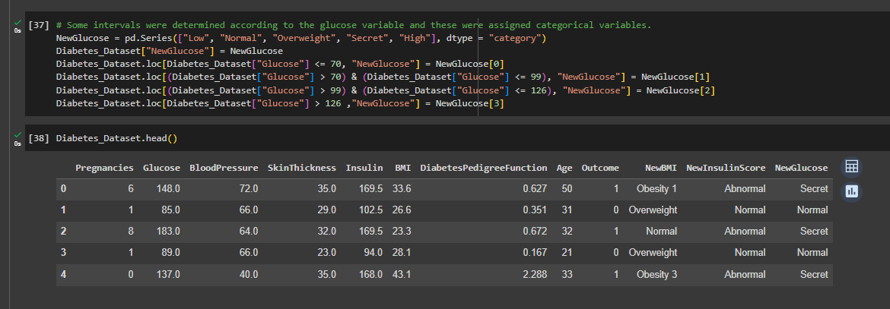

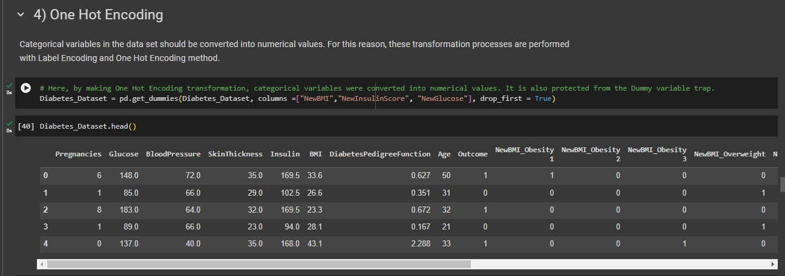

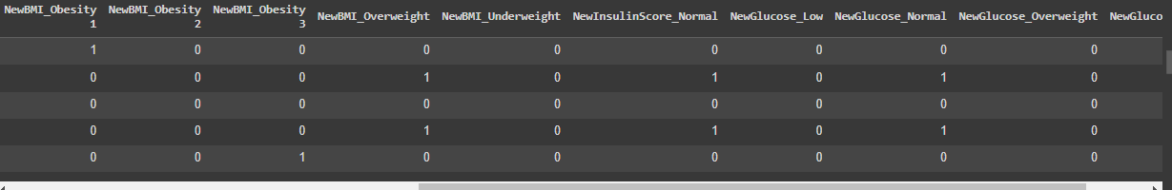

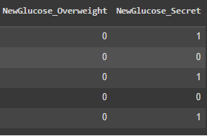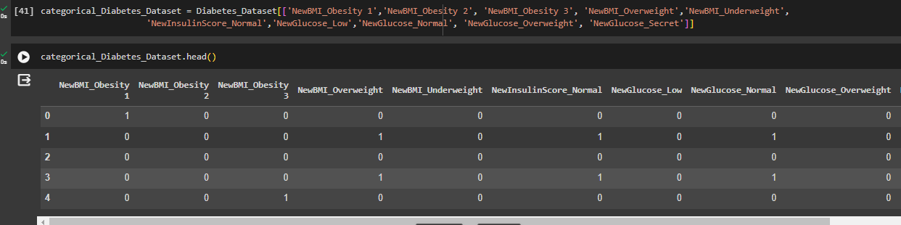

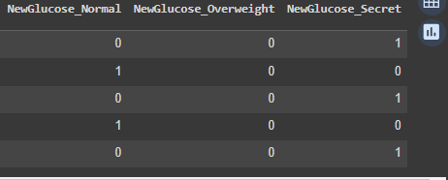

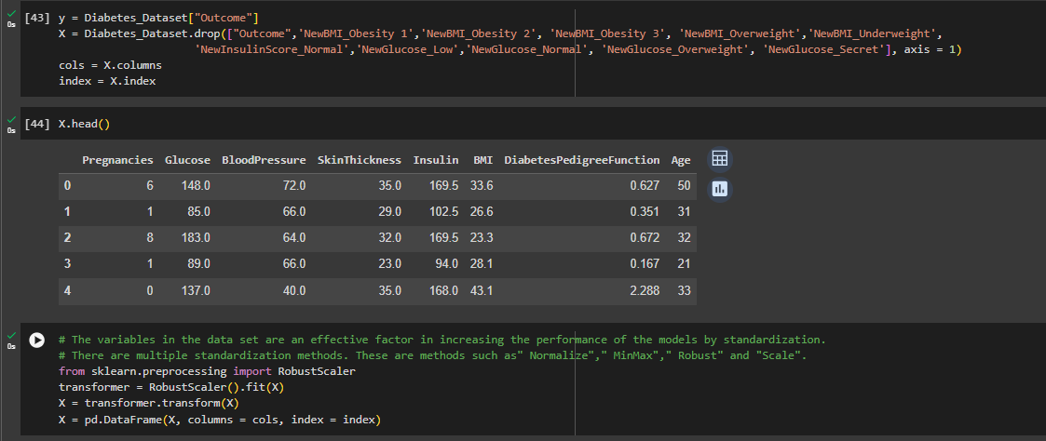

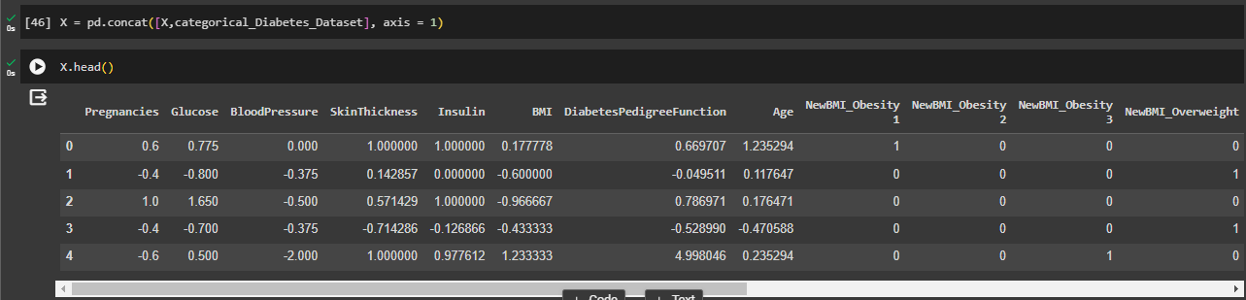

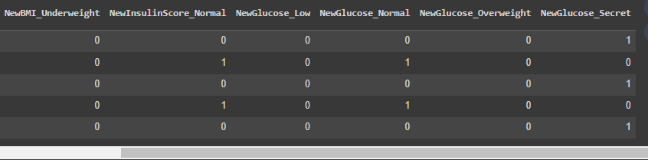

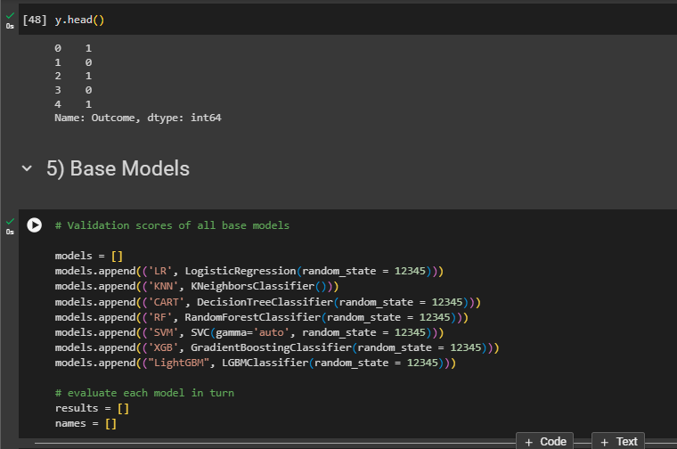

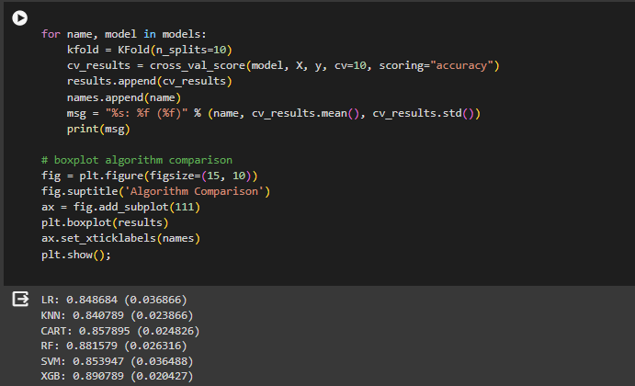

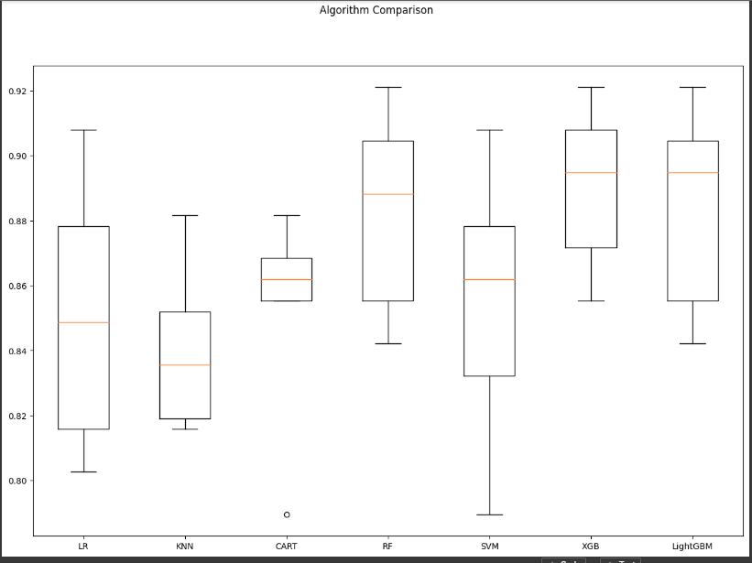

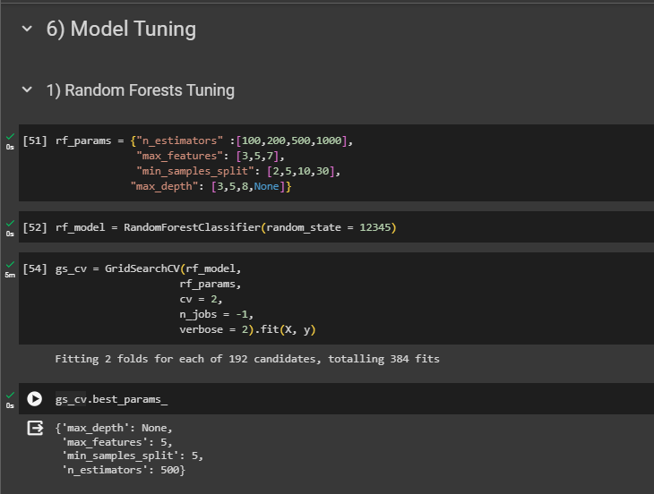

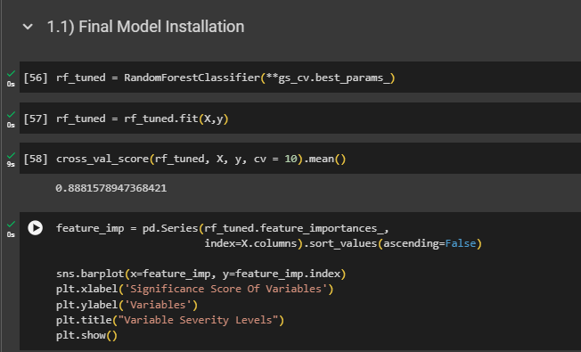

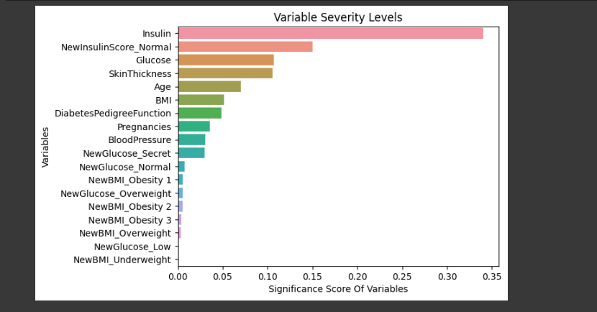

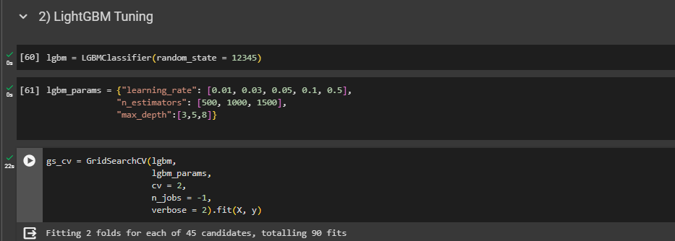

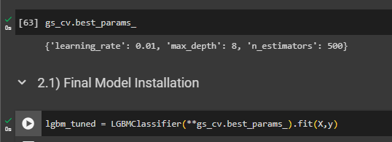



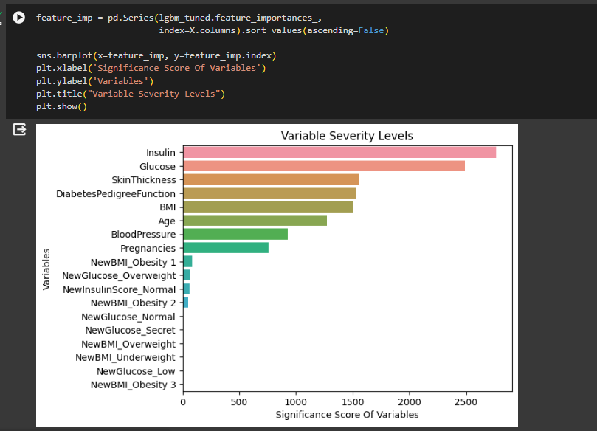

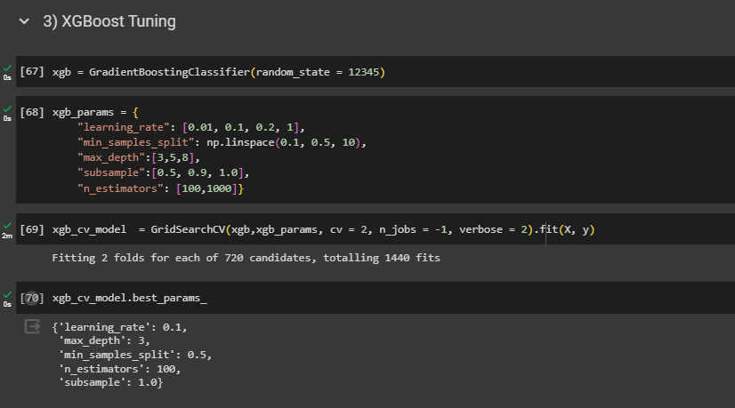

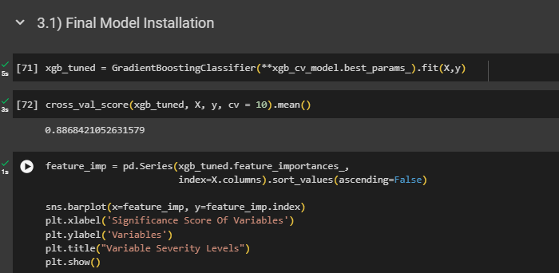

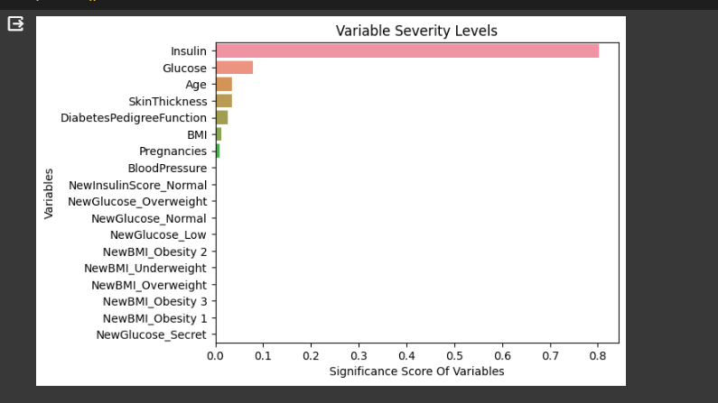

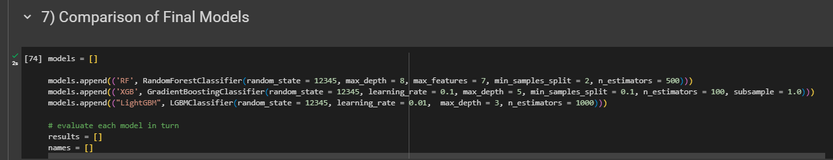

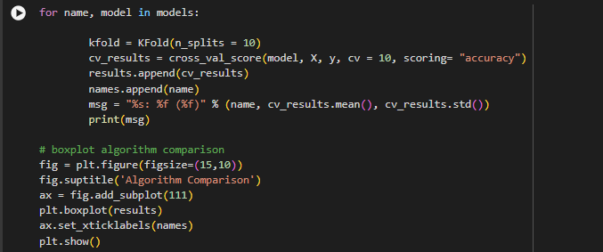



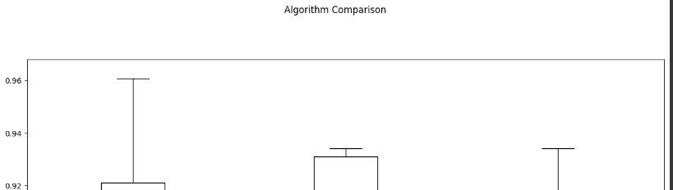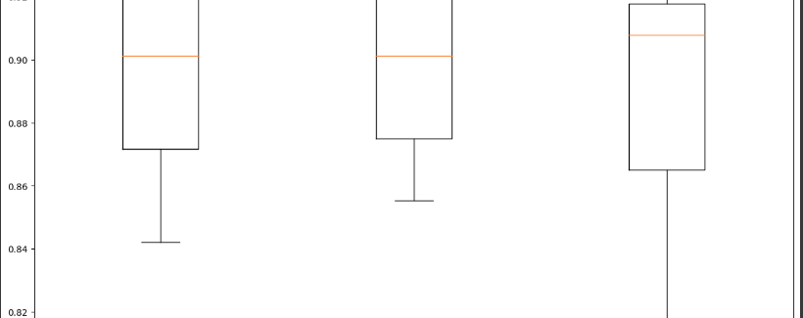



Software construction and development applied to project:

***Key construction Decisions:***

***# 1. Choice of programming language***

Selecting Python as the programming language for our diabetes prediction project is a fantastic choice for several reasons. Python is equipped with an extensive set of libraries and tools tailored specifically for data science and machine learning. With Pandas, NumPy, Scikit-learn, and TensorFlow, we have a powerful toolkit for data manipulation, analysis, and model development.

Python's data visualization capabilities through libraries like Matplotlib and Seaborn are crucial for understanding data patterns and effectively communicating insights. This is particularly valuable as we delve into exploratory data analysis (EDA) and work on interpreting the results of our machine learning models.

Moreover, Python is widely adopted in the machine learning community, and frameworks like Scikit-learn provide a variety of algorithms for classification, regression, and clustering. This aligns perfectly with our goal of predictive modeling for diabetes prediction.

The thriving Python community is an invaluable resource. With a vast network of data scientists, machine learning practitioners, and researchers, we have access to a wealth of resources, tutorials, and expertise. This community support ensures that we can tackle challenges effectively and stay updated with best practices.

Python's versatility extends to interdisciplinary applications, making it suitable for integration into healthcare projects. Many professionals in the healthcare and research domains use Python for data analysis and predictive modeling, making it a natural fit for our project. Considering the abundance of educational resources available for Python, the language is well-suited for projects with a learning or research component. Python's ease of integration also allows us to seamlessly connect different components of our project.

In summary, opting for Python for our data science project, especially for predicting diabetes, is not just a good decision but a widely accepted practice in the data science community. Python's user-friendly nature, extensive libraries, and community support make it a powerful tool for our specific applications.

***Programming Conventions:***

PEP 8, or Python Enhancement Proposal 8, is the official style guide for writing Python code. Created by Guido van Rossum, Python's creator, PEP 8 provides a set of conventions and guidelines to ensure consistency and readability in Python code. Adhering to PEP 8 is considered a best practice in the Python community, and many tools and linters support its recommendations. Key aspects of PEP 8 include: Indentation: PEP 8 recommends using 4 spaces per indentation level. Spaces are preferred over tabs. Maximum Line Length: Lines should be limited to 79 characters for code and 72 characters for docstrings and comments. This ensures code readability in different environments. Import Formatting: Imports should usually be on separate lines, and the standard library imports should be grouped before third-party imports. Whitespace in Expressions and Statements: Avoid extraneous whitespace, such as trailing whitespace at the end of lines. Use a single space around binary operators but not at the beginning or end of a line. Comments and Docstrings: Comments should be complete sentences and follow code changes closely. Docstrings should be used to document modules, functions, classes, and methods. Naming Conventions: Variables, functions, and methods should have descriptive names. Constants should be named in all uppercase. Function and Method Arguments: Don't put spaces around the "=" sign when used to indicate a keyword argument or a default parameter value. Whitespace in Expressions and Statements: Avoid extraneous whitespace, such as trailing whitespace at the end of lines. Use a single space around binary operators but not at the beginning or end of a line. Blank Lines: Use blank lines sparingly but consistently to separate functions, classes, and blocks of code inside functions. Imports: Imports should usually be on separate lines, and the standard library imports should be grouped before third-party imports. Following PEP 8 makes Python code more consistent and readable, which is beneficial for collaboration and maintenance. There are tools, such as linters and autoformatters (e.g., pylint, flake8, black), that help automatically check and enforce PEP 8 conventions in Python codebases.

Indentation:

PEP 8 recommends using 4 spaces per indentation level.

Spaces are preferred over tabs.

Maximum Line Length:

Lines should be limited to 79 characters for code and 72 characters for docstrings and comments.

This ensures code readability in different environments.

Import Formatting:

Imports should usually be on separate lines.

Standard library imports should be grouped before third-party imports.

Whitespace in Expressions and Statements:

Avoid extraneous whitespace, such as trailing whitespace at the end of lines.

Use a single space around binary operators but not at the beginning or end of a line.

Comments and Docstrings:

Comments should be complete sentences and follow code changes closely.

Docstrings should be used to document modules, functions, classes, and methods.

Naming Conventions:

Variables, functions, and methods should have descriptive names.

Constants should be named in all uppercase.

Function and Method Arguments:

Don't put spaces around the "=" sign when used to indicate a keyword argument or a default parameter value.

Blank Lines:

Use blank lines sparingly but consistently to separate functions, classes, and blocks of code inside functions.

Imports:

Imports should usually be on separate lines.

The standard library imports should be grouped before third-party imports.

Following PEP 8 makes Python code more consistent and readable, which is beneficial for collaboration and maintenance. Tools like linters and autoformatters help automatically check and enforce these conventions in Python codebases.